The magazine of the Catholic Diocese of Birmingham
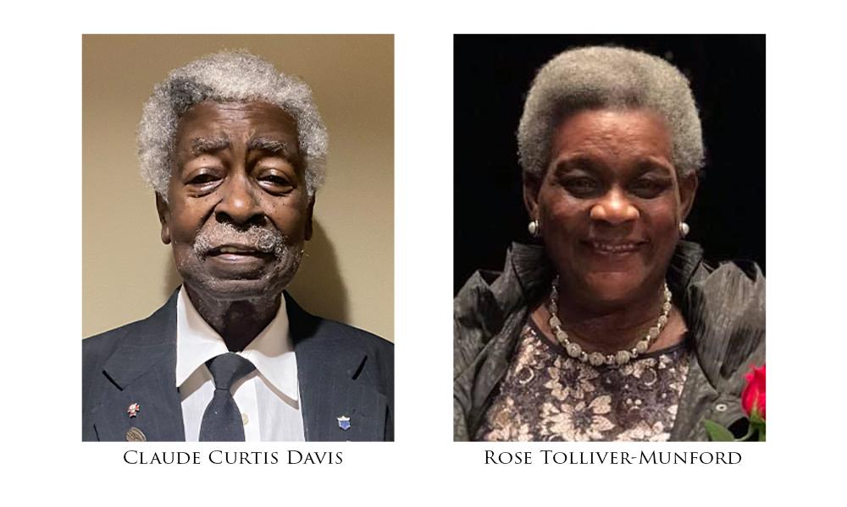
December 2022

2023 Sister Rita Washington Stewardship Award Winners Announced
The Diocesan Office of Black Ministry recently announced that Claude C. Davis of St. Joseph Catholic Church in Huntsville and Rose Tolliver-Munford of All Saints Catholic Church in Anniston were selected as the winners of the 2023 Sister Rita Washington Stewardship Award. Recipients of this award were chosen based on their commitment and stewardship with the diocese, the Office of Black Catholic Ministry, their church, and their community.
Claude Curtis Davis has been a loyal member of St. Joseph Catholic Church in Huntsville for 30 years, serving in many capacities such as organist, lector, extraordinary minister of the eucharist, usher, and bell ringer. Davis’ numerous endeavors of service include participation in the National Black Catholic Congress; help in sponsoring the Annual Valentine Champagne Luncheon for Scholarships, benefitting Holy Family School; participation in St. Joseph’s Fun Day, benefitting the church and school; donation of time to Huntsville’s Downtown Resuce Mission, serving the homeless; participation in Toys for Tots; and organization of St. Joseph’s annual Easter egg hunt. Davis is also a 29-year member of the Knights of Peter Claver Council 286. He is a 4th degree member of the Knights of Columbus, a lay member of the Society of the Divine Savior, and a father of two sons.
Rose Tolliver-Munford resides in Anniston, retired from the Fort McClellan Army National Guard Training Center as an environmental technician with twenty-six years of federal service for the Department of Defense. Before her federal service, she received a Bachelor of Science in Nursing from Lurleen B. Wallace School of Nursing and served 37 years as a medical-surgical nurse and 20 years in the United States Army Reserve (USAR) as a clinical nurse for the 75th Combat Support Hospital Unit in Tuscaloosa. She is the mother of two daughters. She also established the All Saints Creative Arts Center, Inc., and the Cheaha Creative Arts, Inc. She has served as the director of religious education for All Saints Roman Catholic Church in Anniston and as a member of the Anniston Historic Preservation Commission. In 2019, she was named the Anniston Star 2019 citizen of the year.
On Jan. 8, 2011, the Office of Black Catholic Ministry established the Sister Rita Washington Stewardship Award in honor of its first director, Sister Rita Washington, SFCC. Sister Rita served in the diocese at St. Martin de Porres Church and School in Gadsden for three years and in Birmingham as the founder and director of the Office of Black Catholic Ministry for eight years. Sister Rita died on Aug. 13, 2018.
Realizing the diocese is full of people choosing to be good stewards of the gifts they possess, the Office of Black Catholic Ministry wanted to express its appreciation. Those recognized don’t look for recognition or praise. They freely give of their time, talent, or treasure. They have committed their very selves to the Lord.
Past recipients include Sister Rita Washington, Rose T. Sturdivant, Jane Sweeney, Reba Watts, Father Vernon F. Huguley, John and Lenora Bolling, Richard Harris, Horace Garland Jackson, Deacon Walter Henderson, Thomessia Moore-Lawson, Olivia Hill, Oather Jones, Diane Greene, Bruce and Helen Taylor, Cleophos Vann, Al Sims, Trudi Stinson, Deacon Douglass Moorer, and Angela Rembert.
The award is presented at the Diocesan Martin Luther King, Jr., Prayer Breakfast. The 2023 breakfast will be Saturday, Jan. 14, starting at 10 a.m. at the Cathedral of St. Paul’s Life Center.

